**DFS INVESTMENT MODEL**

DFS Portfolio Model

**SUMMARY**

**April 2016**

## DFS Approach to Strategic Asset Allocation

Of all the investment decisions involved in portfolio management, the strategic asset allocation (SAA) is perhaps the most important. Given two portfolios, differences in their SAAs is generally the most significant driver of different return experiences. Most importantly, the SAA drives the portfolio’s risk profile. To a portfolio manager, investors differ most in the amount and types of risk that they are willing to take on.

DFS Portfolio Solutions uses a sophisticated quantitative process to determine the strategic asset allocation of its model portfolios. Quantitative finance provides a more rigorous approach to investment management. It began in the 1950s with the development of Modern Portfolio Theory. Over the ensuing decades, the profession’s understanding of market behaviour has advanced considerably; however, these developments have been applied somewhat patchily by practitioners.

## Modern Portfolio Theory

In order to understand the DFS Model, it’s best to start at the beginning – that is, with Modern Portfolio Theory (MPT). Before MPT, asset allocation meant little more than trying to outdo other managers in picking underpriced securities. This is still a vital part of the industry, but it has some limitations:

* It’s a zero-sum game. For every investor who thinks the price of an asset is too low, there’s another who thinks it’s too high – otherwise, demand pressure would have already raised the price. They can’t all be right; on average, investors do only as well as the market, because taken together, investors are the market.
* It doesn’t account for risk. Whether or not a security is fairly priced, its future return is uncertain. A portfolio of assets with good return expectations but high volatility could be at risk of large losses – more risk than the investor is willing to take on.
* It treats assets individually, without regard for how they behave in a portfolio of other assets.

Modern portfolio theory filled the gap. MPT’s investment world has these characteristics:

* Investors are risk averse –all else being equal, they prefer a more certain return to a less certain one. Put simply, they seek to maximise return and minimise risk. These two goals naturally conflict with each other; an optimal portfolio represents a trade-off between the two.
* When investors trade-off between risk and reward, ‘reward’ means the **expected (average) return** and ‘risk’ means the **variance**, or equivalently the standard deviation.[1] This is a measure of the dispersion of returns about the average.
* **Diversification** matters. The risk and reward that an investor cares about are not those of individual assets, but of their portfolio as a whole. An asset’s impact on the portfolio’s volatility depends not just on its own standard deviation, but on its correlation with the rest of the portfolio. If it has a low correlation, its return movements tend to offset the rest of the portfolio, reducing the overall volatility. On the other hand, a high correlation means that the asset’s behaviour tends to mirror what the rest of the portfolio is doing, and offers little diversification benefit. In addition to high returns and low standard deviations, investors prefer assets with low correlations.

For any given level of risk (volatility), we can find the portfolio that maximises reward (expected return). The set of all such portfolios over all values of risk is called the **efficient frontier**. Each portfolio on this frontier represents an optimal trade-off between risk and return. Investors can choose from this set the optimal portfolio with the risk-return profile they prefer.

The following chart shows an efficient frontier, derived from a set of available assets. The efficient frontier offers better outcomes than any of the individual assets (for any given asset, we can find a portfolio on the frontier with higher return, lower volatility, or both). This is due to the diversification benefits, as described above.

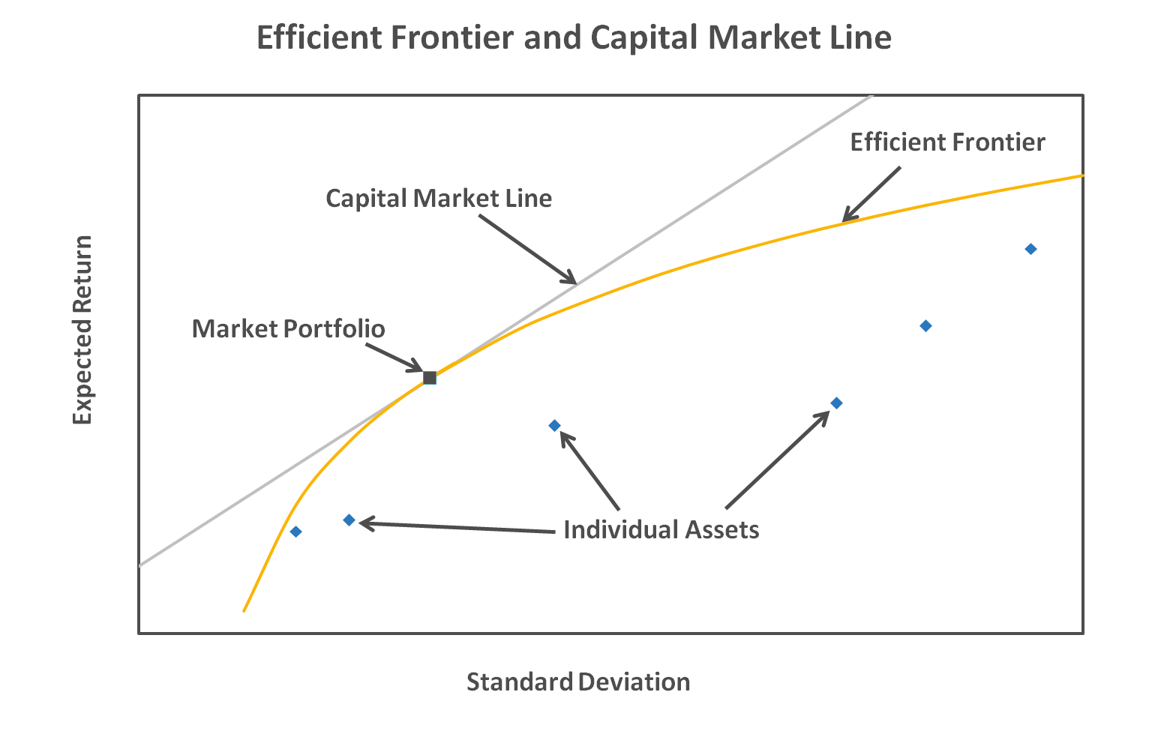

The **Capital Asset Pricing Model (CAPM)** added the conclusion that all investors would be best off by simply holding assets in proportion with their overall market share; to reach their desired risk level, they either keep part of their money in cash, or borrow more money in order to leverage their investments. This is denoted by the Capital Market Line in the chart, above.

Many assumptions go into MPT – assumptions which, to one degree or another, do not hold in practice. Much of the development of financial theory since then has involved determining the impact of the differences between the world described in MPT and the real world, and finding other ways to address its shortcomings. That leads us in to the DFS Portfolio Model – the principles on which it is based, how it has been constructed, and how it improves our investment process.

## The DFS Portfolio Model

During the Global Financial Crisis, when markets around the world plummeted together, many investors were surprised to find just how little downside protection their supposedly diversified portfolios offered them. Certainly an event of such magnitude is likely to overwhelm any previous expectations; but to some extent, that merely proves the point. The investment outlook conditioned by Modern Portfolio Theory sees markets as fundamentally well-behaved; events like the GFC (and before that, the bursting of the tech bubble, the Asian financial crisis, Black Tuesday in October 1987 – Black Monday elsewhere in the world – and so on) simply shouldn’t happen as often as they do.

Our goal in building the DFS Portfolio Model is to incorporate the best advances in the profession’s understanding of risk, in order to improve the risk management of our model portfolio SAAs. In its broadest outline, our procedure is very similar to that presented in Modern Portfolio Theory – determine an appropriate level of risk for each model portfolio, then optimise the level of reward provided by the chosen portfolio. However, the details differ significantly, to provide a better picture of market risk – especially the chance of significant losses.

The assumptions behind the latter theory have inadequately captured some features of market risk – and this is where and why the DFS Portfolio Model differs from MPT. These shortcomings in MPT thus signpost the development of the DFS Portfolio model; the remainder of this section provides those signposts.

## Risk factors are not limited to the broad market

CAPM reaches the conclusion that the only risk factor that matters to investors is exposure to movements of the overall market. Any other risk can be effectively negated by holding a diversified portfolio. An asset’s exposure to market movements is termed its market beta – the higher the beta, the greater the asset reaction to market movements.

Studies have shown, however, that market beta alone is a poor predictor of asset returns.[2] This is partly due to shortcomings in the assumptions on which CAPM is based, and partly on the difficulties in estimating market beta in the first place. In practice, other factors beyond market beta have been shown to drive returns. This makes intuitive sense; markets are complex, and it’s very easy to come up with counter-examples against the CAPM conclusion. For instance: airlines and oil companies might both be expected to rise with the market when times are good. They both experience higher demand for their product. However, they would react very differently to a sudden spike in the price of oil. The oil company will do well as its revenues rise; but the airline will be squeezed as fuel costs, one of the major expenses facing an airline, blow out. Likewise, when the Australian dollar falls, exports receive a boost but imports become more expensive. An export-driven firm will benefit; an importer will suffer. Such risks are not specific to one firm – they will affect a wide range of possible investments, and thus are not so easily diversified away.

An alternative model of asset returns, Arbitrage Pricing Theory (APT), was developed in the 1970s. Under this theory, returns are driven by a number of risk factors; investors are rewarded (penalised) to the extent that they are exposed to any or all of these risk factors. The assumptions that go into this theory are much simpler, and more realistic – essentially it requires only that markets offer a diverse range of assets with different risk exposures which investors can trade freely. However, unlike CAPM, it does not provide guidance as to which drivers should be included as risk factors. There are a variety of possible approaches to identifying risk factors.

The DFS model is an APT factor model. We model a number of risk factors and estimate the level of exposure of each asset class to the different factors. A factor model gives us a richer picture of the relationships between asset classes. As asset classes are broad categories of assets, we use broad macroeconomic indicators as our risk factors. They are: (1) equity market risk; (2) price inflation; (3) currency movements; and (4) movements in interest rates.

## Risk involves more than variance

Picture an investor who currently holds a risky portfolio. Over the next year, the portfolio could make a gain, or make a loss (hopefully gains are more likely than losses). Now the investor is offered a new investment. Compared to the old portfolio, any losses will be exactly the same; however, the new portfolio doubles any gains the old portfolio would have made. Is this a riskier investment?

Most investors would say no. Compared to the first portfolio, they can only do as well or better. However, if we were to measure risk solely by (the MPT approach of) variance, the answer would be yes. The dispersion of returns has increased, as we’ve ‘pushed out’ all the positive returns.

The reason for the disconnect is that investors care more about the downside. Variance is a sensible risk measure insofar as it measures the possible size of losses. There are cases, however, where variance can understate or overstate the risk of losses. Two assets could have the same variance, but one carries significantly higher risk of large losses than the other. (We will cover later some statistical properties of the distribution of returns that can make this happen.) In those cases, we don’t expect investors to care just about the variance. We expect them to prefer the asset that carries less downside risk.

There are a number of risk measures that are based on downside risk. One of the best-known is Value at Risk (VaR). The VaR is the size of the loss that an investor might expect to face over a given time horizon with a given level of probability, for instance: “this portfolio has a 5% chance of losing at least 3% of its value over the next month”. In this example, the 5% VaR over a month’s time horizon is -3%.

VaR gives us more information about possible losses than does variance. However, it doesn’t tell us much about losses even more extreme than the VaR level itself. In our example, we know the chance of losing at least 3%. It doesn’t tell us much about how bad it could get past that point. A more informative measure is the Expected Shortfall (ES). This measure begins with the VaR at a certain cut-off point; it then calculates the average loss, *given that* the loss is at least as bad as the VaR. The following chart demonstrates the relationship between VaR and ES:

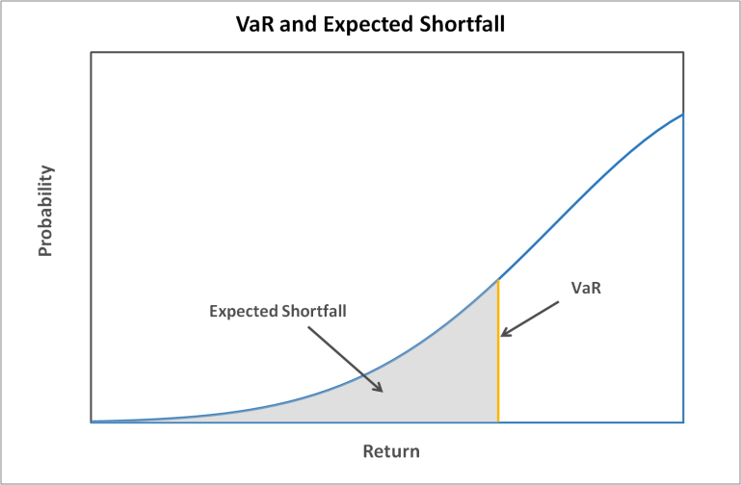

When setting the SAA for our model portfolios, we budget for risk using the Expected Shortfall (past a 5% likelihood, at an annual time horizon) rather than the variance. We calculate both measures; however, we believe ES better describes investor concerns when addressing risk.

## Expected return is an incomplete measure of reward

As a corollary, if investors are more worried about the downside than the upside, expected return is a flawed measure of investment reward. To a risk-averse investor, the chance of a given loss is not offset by an equal chance of an equal gain. Although the expected return is unchanged, it now comes with greater risk, which in the eyes of a risk-averse investor needs to be compensated. In economic terms, this investor faces **diminishing marginal utility** from increases in wealth. This principle states that an extra dollar is worth less to you, the more you already have to begin with. Gaining $1,000 means far more to a pauper than to a millionaire.

We can account for the utility provided by investment gains via a utility function. Such a function transforms dollar values into utility values. (These utility values are entirely artificial. The amount doesn’t matter at all; what does matter is their relative behaviour – that is, that they behave sensibly when we compare different utilities from different dollar amounts.) Good utility functions show diminishing marginal utility; more wealth always means more utility, but the rate slows down as wealth increases. Some examples appear in the following chart. The greater the degree of risk aversion, the more the utility ‘flattens out’ at higher levels of wealth.

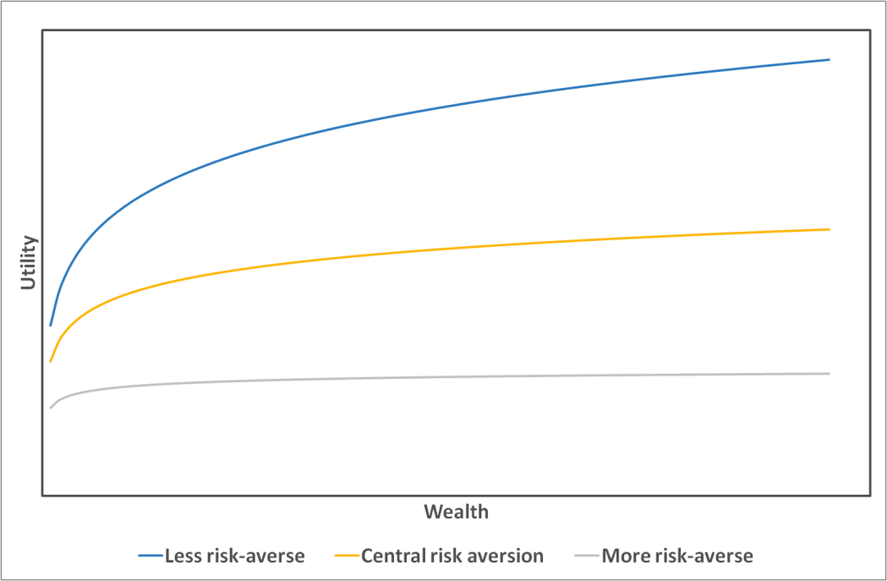

DFS uses expected utility as the reward measure for a portfolio. Expected utility has been found to better describe the choices people make in the face of uncertainty, and compared to expected return, it better encapsulates the actual benefit they get from investment returns. The impact of doing so is that the downside is given greater weight and the dollar value of the upside return is somewhat discounted. It once again emphasises our commitment to providing investors with superior protection against loss.

## Returns are not well-behaved

A fair question concerning expected shortfall and expected utility, is: does it matter? If market returns are well-behaved (that is: if, for instance, they all follow the normal distribution) then we can use ***either*** (MPT based) mean-variance or (the DFS approach of) expected utility-expected shortfall to find the optimal portfolio, and they would give the same answer. However, historically, ***markets have not been well-behaved***. There are two other statistical measures that affect downside risk, and historical returns do not behave normally against either of them.

* **Skewness.** A normal distribution is symmetrical. Returns above the mean are just as likely as returns below the mean. This is not the case with historical returns. For most assets, especially over shorter time periods, returns show negative skew – that is, unusually poor returns are more likely than unusually good returns. The greater the negative skew, the greater the downside risk.
* **Kurtosis.** This measures whether a distribution tends to have a relatively peaked centre and long (or fat) tails, or a fairly flat centre and short (or thin) tails. Distributions with high kurtosis (called ‘leptokurtic’) carry more of their weight in the tails; in other words, extreme results are relatively more likely compared with a short-tailed (‘platykurtic’) distribution. The higher the kurtosis of a return distribution, the greater the risk of extreme losses.

The two graphs below show the impact of changes in skewness and kurtosis.

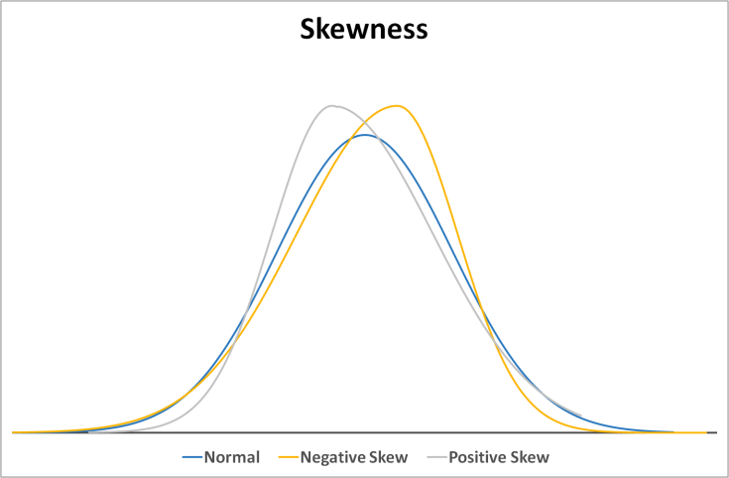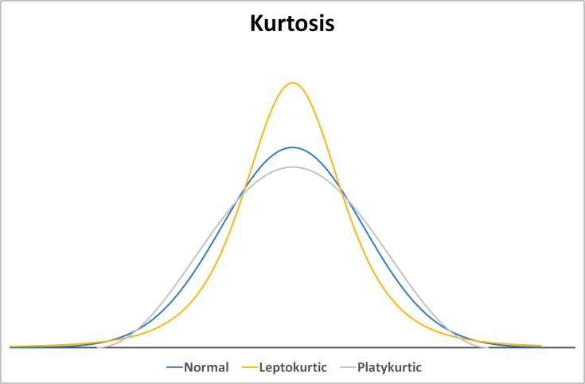

Market returns for most assets show negative skew and high kurtosis. Both features increase the downside risk. A model that assumes returns follow the bell curve will ignore much of the risk of large losses. If we look just at the tail, the difference in the distributions looks like this:

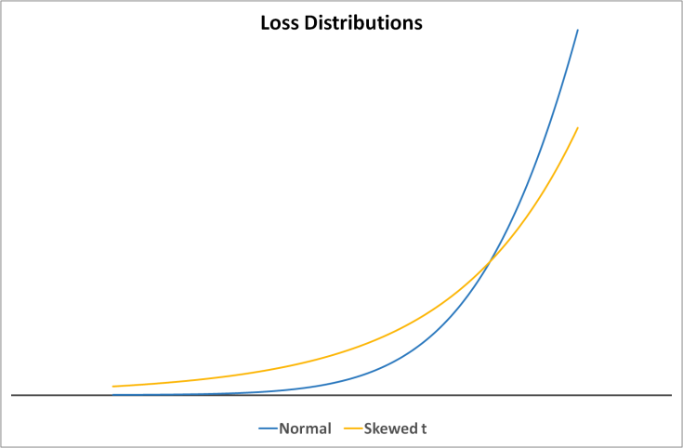

The distribution with negative skew and high kurtosis is much fatter in the tail, showing a greater risk of losses, and higher losses when they do occur.

Given that historical returns have not been well-behaved, we base our return distributions, not on the normal distribution, but on the generalised lambda distribution. This distribution has parameters that control the level of skew and kurtosis, allowing the creation of negatively skewed, fat-tailed distributions, or positively skewed, thin-tailed distributions, or anything in between. The exact parameter values are estimated using historical data.

## Markets are not stable

One of the most enduring assumptions about market returns was that they are stable – the risk in one month is much like the risk in another. Once again, this has proved to be unrealistic, especially with respect to the degree of volatility in the market. In recent times, for instance, the period from about 2003 to 2006 was an unusually stable one for markets, with low inflation and fairly stable investment markets. The same was true for much of the 1990s. Conversely, events such as the bursting of the tech bubble in 2000 and the GFC in 2008 were followed (and preceded) by periods of turbulence, raising risk levels.

A more subtle issue is that during these periods of turbulence, correlations between asset classes also rise. In normal markets, the international equity market may be rising on the whole, but individual countries may rise or fall depending on local factors. However, in the GFC, asset classes all fell together.

The danger in rising correlations is the impact on diversification. Investing over different asset classes is supposed to reduce a portfolio’s overall risk levels – losses in one class will likely be offset by another’s gains. However, when markets suffer a severe shock – just when an investor most wants the benefits from diversification – those benefits can evaporate.

Our model does not assume static markets. We use a family of models called GARCH models, developed in the 1980s. In these models, markets react to shocks (large swings in asset values) by becoming more volatile for a period. The larger the shock, the greater the impact on volatility. There are a number of variations on the basic model that have been developed, with different characteristics. Some features of market risk that we have captured within our model include:

* Volatility of risk factors varies over time.
* Negative shocks (large losses) have a greater impact on volatility than do positive shocks.
* When markets are turbulent, correlation between asset classes rises, reducing diversification.

Capturing the dynamic volatility in the market gives two advantages over models that assume volatility remains unchanged. First, if volatility is dynamic, then (once again) the risk of large losses goes up. Turbulent markets are prone to big swings; ignoring them means that the risk of loss is understated.

Second, estimating such a model allows us to detect changes in market conditions, and adjust our portfolios accordingly. Where levels of volatility have increased, so will the level of risk within a given portfolio. By taking a more defensive position at these times, the portfolio’s risk levels may be maintained at the desired level. Likewise, during stable periods, we can take on more aggressive assets without exceeding desired risk levels.

The following chart shows estimates of volatility in world equity markets, both using a GARCH model and simply taking the average volatility over the last year. The chart makes clear that the level of risk in the market has undergone big swings over the last decade or two. Compared to the rolling average, GARCH estimates of volatility are more responsive to immediate conditions; in particular, the rolling average tends to overstate the time it takes for markets to settle down again after a shock. This greater responsiveness pays off in the ability to adjust portfolio holdings more rapidly to changing market conditions.



The next chart shows how a dynamically managed portfolio allocation would have changed in response to shifting market conditions over the last two decades.



During the bull runs of the late ‘90s and the mid-‘00s, markets were relatively stable and volatility was low. At these times, to maintain the same risk profile, a dynamically managed portfolio would take on more growth assets, and prefer assets with greater market exposure. Risk was well rewarded during these periods; a more aggressive tilt would have improved returns. Contrast with the bursting of the tech bubble and the onset of the GFC. In both cases, volatility had risen even before the onset of these crises. A dynamic portfolio responds to this signal by tilting towards defensive assets and seeking non-traditional diversifiers, such as gold. Such a portfolio is better protected when crashes occur.

Nonetheless, looking at the GFC especially, this signal alone would not have predicted the magnitude of the coming market crash. In fact, we find that risk budgeting has had the greatest positive effect on returns during stable bull markets.

There can be times too when an increase in volatility coincides with increased returns. The aim of dynamic risk management is to maintain a desired level of risk protection. In this regard, any return enhancing objective (which relies on uncertain forecasts) is incidental to risk management.

## Equity markets are prone to shocks

Over the last 43 years, there have been 16 occasions when the Australian stock market has lost over 10% of its value.[3] On three of those occasions it lost over half of its value. On average, it took seven months to go from peak to trough – and another 18 months to recover the lost ground. At worst it can take years. Other equity markets exhibit similar patterns – investing in growth assets leave investors exposed to the risk of substantial losses.

The price fluctuations typical of equity markets will generally be recovered quickly; however, an overvalued market can suffer significant losses that impair the portfolio’s value for months or years. Downside risk management is largely concerned with mitigating or avoiding the losses during these bear markets.

## DFS dynamic risk management

DFS manages its portfolio allocations dynamically via two complementary processes:

* Dynamic risk management
* Stop-loss protection

### Dynamic risk management

Dynamic risk management (DRM) operates within a risk budgeting framework. We target a stable level of the portfolio’s volatility. When market volatility changes, so does the portfolio allocation – we put more into growth assets when volatility is low, and more into defensive assets when it is high. Compared to holding a static asset allocation, this approach gives investors a more predictable risk profile.

In back-test, this approach adds solid value during bull markets. (This is also the case in live results.) Low-volatility markets have also tended to post strong returns; overweighting growth assets at these times is rewarded. Conversely, it tends to react late to jumps in market volatility, which are typically prompted by a crash. The portfolio may therefore still be overweight in growth assets when the initial shock hits, and it can underperform.

### Stop-loss protection

The stop-loss mechanism seeks to protect investors from crashes in equity markets. We monitor each equity market individually for signs that its valuation has outstripped its fundamentals. Such a market is at greater risk of a price shock – and when such a shock occurs, it potentially has further to fall.

Even so, when we receive such a signal, we do not take any immediate action. Historically, such markets have been able to maintain their momentum for some time. Famously, in December 1996, Alan Greenspan warned that markets might be inflated by “irrational exuberance”. It took another three years of stellar returns before the dotcom bubble burst.

Once we have identified an overvalued market, we monitor it for signs that price support is softening. When that happens, the market is at risk of a crash. We sell out any passive investment in that market into cash, until such time as price support has returned.

The following chart shows how this operates, on the MSCI World Index.



The shaded area shows the growth in the MSCI World index. The periods shaded in orange are times when overvalued markets coincide with softening price support. The solid line shows how this strategy has performed.

Such a stop-loss strategy can protect investors from market crashes because such crashes typically take time to unfold. Events like the Black Monday crash in 1987 are the exception, not the rule. However, the protection comes at a cost. It is likely that where a market has become overheated, there will be one or more false starts before it finally falls. At these times, the strategy will pull out of the market prematurely, and the investor will miss some of the upside.

This is the opposite pattern from the dynamic risk management process. DRM adds value during bull markets but can detract at the outset of a bear market. Stop-loss protects investors during a bear market, but false starts will cost them in the bull market. The two process thus complement each other. In each case, in back-tested results the positive impact on returns has been stronger. The overall process has added value in both bull and bear markets.

However, although we expect the processes to have a positive impact on returns, they are both driven by risk management considerations – in the case of DRM, using the traditional notion of risk as volatility, while in the stop-loss case, managing the downside risk of market crashes.

## Appendix – DFS Portfolio Model vs Modern Portfolio Theory

We conclude with a side-by-side comparison of the investment world according to MPT and the DFS Portfolio Model. In short: markets carry significantly greater risk of large losses than implied by Modern Portfolio Theory, and investors care about the chance of such loss. The DFS Portfolio Model is designed to capture that risk; our portfolios, based on this model, thus provide investors with better protection against the investment dangers that matter to them.

|  |  |  |
| --- | --- | --- |
| **Modern Portfolio Theory** | **DFS Portfolio Model** | **Impact** |
| Seeking reliable investment returns involves a trade-off against risk | Seeking reliable investment returns involves a trade-off against risk | Changes the nature of investment management from simply seeking mispriced valuations to managing investor risk. |
| Diversification reduces risk | Diversification reduces risk | Manage assets as a portfolio, not just as a collection of individual choices |
| CAPM: The only risk factor that matters is exposure to the broad market | APT: Asset class returns are influenced by a number of broad market and macroeconomic factors | Richer picture of risk characteristics; can manage portfolio exposure to different risks |
| Returns are relatively well-behaved | Returns can have fat tails and be significantly skewed | MPT understates the risk of large losses |
| Variance of returns covers investment risk | Investors care more about downside risk; variance is insufficient | Investors care about the risk of large losses, and prefer portfolios that offer downside protection |
| Investors seek to maximize expected return | Investors seek to maximize expected utility | Loss aversion affects how investors view wealth and returns |
| Returns are stable over time | Markets experience periods of stability and turbulence; market risk can vary widely from period to period | A given portfolio must be managed dynamically to maintain a desired risk profile |

Our goal of protecting investors on the downside is not necessarily free. If investors care about downside risk, we expect that there will be a trade-off between risk and reward. The measures that we take, however, may be return-neutral or even beneficial. For instance, the goal of dynamic risk management is to manage the risk profile; it also has the potential to enhance returns, by raising or lowering market exposure at the times when it pays to do so.

### Use of Material and Information

The information and material provided in relation to the DFS Investment Methodology (**Information**) is proprietary to DFS. Unless expressly stated otherwise, DFS claims copyright ownership of all Information in respect to its Investment Methodology. The Information may be used for the purposes of private study, research, criticism or review, as permitted under the Copyright Act 1968. You are not permitted to re-transmit, distribute or commercialise the information or material without seeking prior written approval from DFS. Where permission is obtained, the Information must be reproduced in its unaltered form and must acknowledge DFS as the source. DFS reserves the right to revoke such permission at any time.

**END OF REPORT  
DFS Investment Research – April 2016**

1. In this document, we use the terms standard deviation and volatility interchangeably.
2. The researchers Eugene Fama and Kenneth French have mounted possibly the best-known investigations into CAPM. Their paper, “The Capital Asset Model: Theory and Evidence” (2004), provides a strong analysis of CAPM’s poor performance in practice.
3. Using the All Ordinaries to May 1992, the ASX 300 thereafter.